Assignment 12
Assignment – Open-Source Collaboration – Fork, Sync & Pull Request
Task 1
Task 0
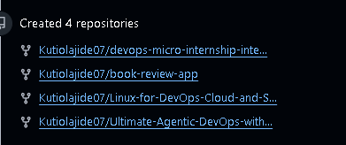
Screenshot 1
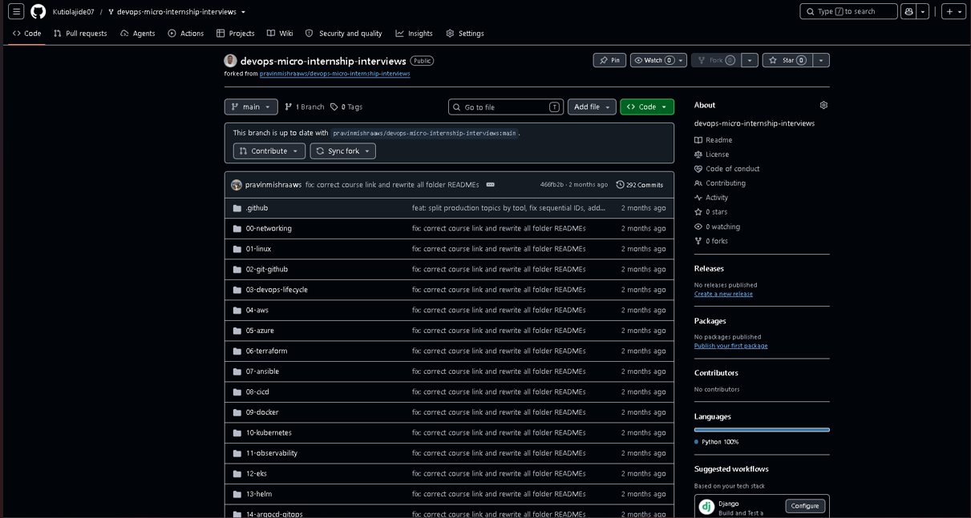
Screenshot 2
Task 2
Screenshot3
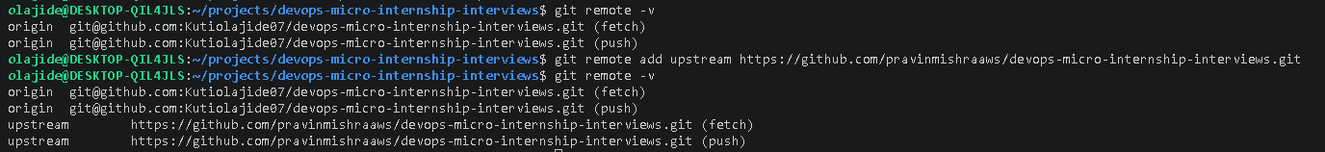

Task 3
Screenshot 4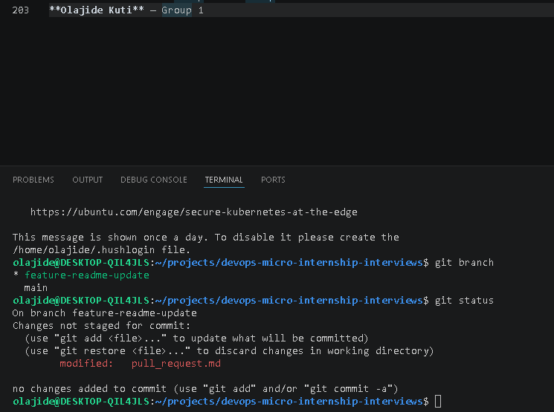
Screenshot 5
Task 4
Screenshot 6
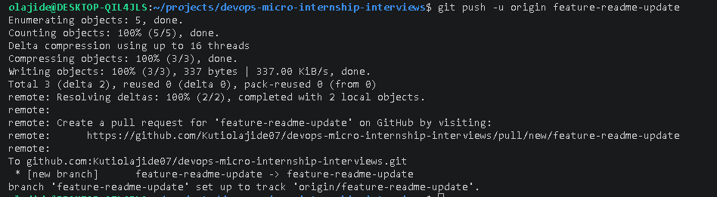
Screenshot 7
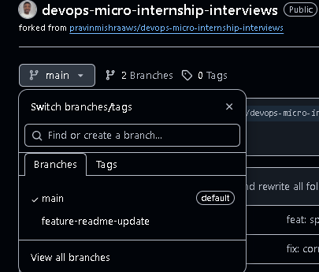
Screenshot 7 a
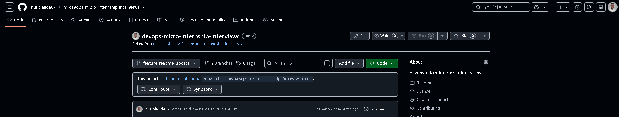
Screenshot 8
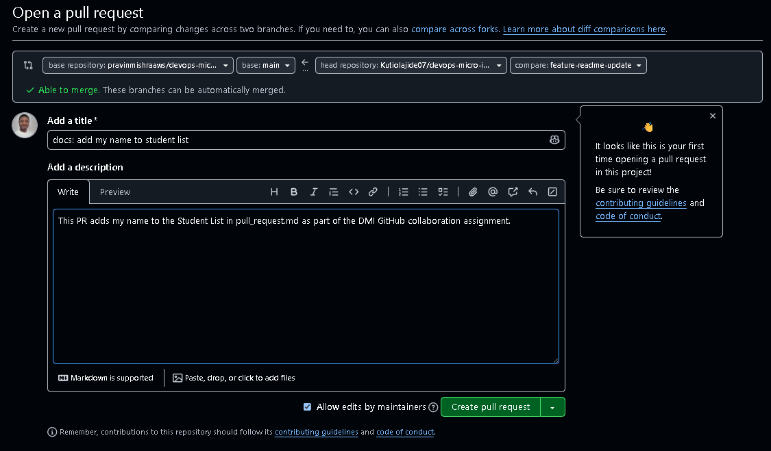
Screenshot 9
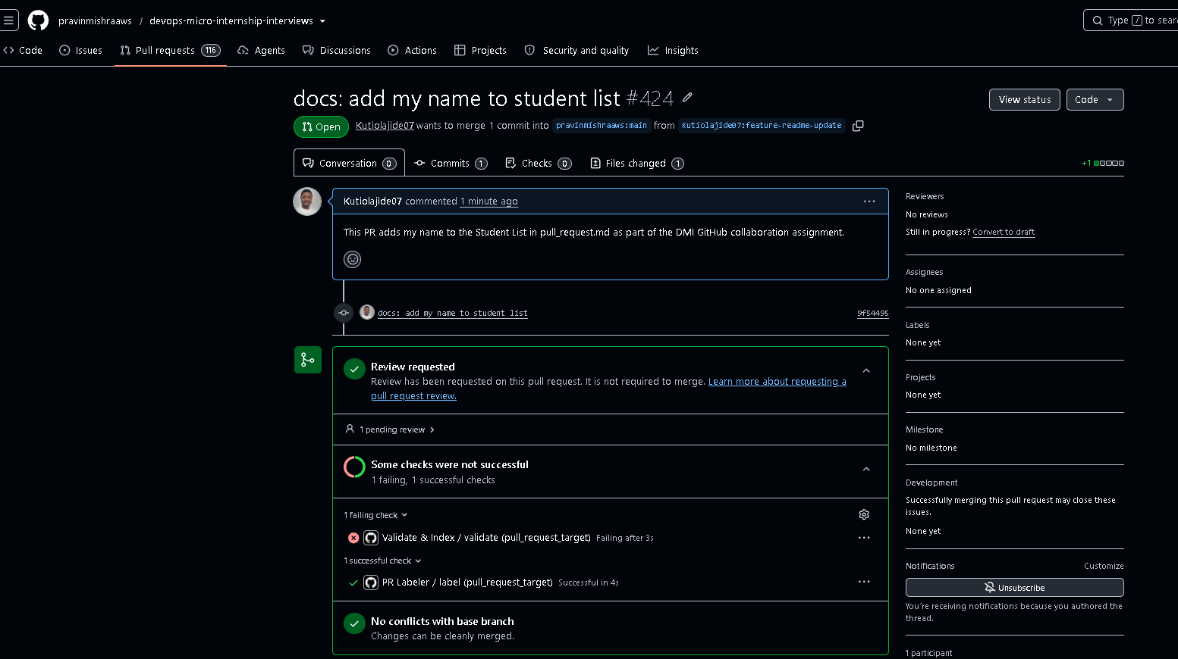
Blog post/Website
Continuous learning is one of the most valuable investments any technology professional can make.
Having spent the last several years working across Microsoft 365 and Azure environments, strengthening my DevOps capabilities complements the operational, cloud, and security work I already do. Understanding how infrastructure, automation, version control, and collaboration fit together is becoming increasingly important across cloud engineering and cybersecurity.
I have just completed a project as part of the DevOps Micro Training Program, focusing on collaborative software development using Git and GitHub.
The project included a complete Git workflow, including:
- Configuring SSH authentication with GitHub
- Working with forked repositories and upstream remotes
- Creating and managing feature branches
- Following a structured commit strategy
- Raising and submitting a Pull Request through GitHub
Contribution: I contributed to the upstream repository by updating the pull_request.md file through a feature branch, committing the change using a structured commit message, pushing it to my GitHub fork, and creating a Pull Request following the standard GitHub collaboration workflow.
Learning: This project strengthened my understanding of collaborative development using Git and GitHub, including working with forks, upstream remotes, feature branches, SSH authentication, and the Pull Request review process. It also reinforced the importance of version control and collaborative engineering practices in modern DevOps environments.
Every hands-on project reinforces not only technical skills but also the engineering practices that enable teams to build, review, and deliver changes in a structured, reliable, and collaborative way.
Many thanks to Pravin Mishra and everyone involved in the DevOps Micro Training Program for designing practical environment that reflect real-world engineering workflows.

